EXTRA – CURRICULAR ACTIVITIES

DATABASE PROJECT REPORT

**SUBMITTED BY**

|  |  |
| --- | --- |
| **Name: Ashika C S** | **USN: 1MS17CS017** |
| **Name: Ambika G** | **USN: 1MS17CS008** |
| **Name: Mallika Ravi** | **USN: 1MS17CS057** |
| **Name: Lakshmi Itagi** | **USN: 1MS17CS049** |

As part of the Course **Database Systems– CS52**

SUPERVISED BY

Faculty

SINI ANNA ALEX

ASSISTANT PROFESSOR

DEPARTMENT OF CSE



DEPARTMENT OF COMPUTER SCIENCE AND ENGINEERING

RAMAIAH INSTITUTE OF TECHNOLOGY

Aug-Dec 2019

Department of Computer Science and Engineering

Ramaiah Institute of Technology

(Autonomous Institute, Affiliated to VTU)

Bangalore – 54

**CERTIFICATE**

This is to certify that **Name: (USN:)**, **Name: (USN:)** have completed the **“Extra-Curricular Activities”** as part of Database Project. We declare that the entire content embodied in this B.E. 5th Semester report contents are not plagiarized.

Submitted by Guided by

|  |  |
| --- | --- |
| Name: Ashika C S | USN: 1MS17CS017 |
| Name: Ambika G | USN: 1MS17CS008 |
| Name: Mallika Ravi | USN:1MS17CS057 |
| Name: Lakshmi Itagi | USN: 1MS17CS049 |

Sini Anna Alex

(Dept of CSE, RIT) (Assistant Professor, Dept. of CSE, RIT)

Department of Computer Science and Engineering

Ramaiah Institute of Technology

(Autonomous Institute, Affiliated to VTU)

Bangalore – 54

**EVALUATION SHEET**

|  |  |  |  |  |  |
| --- | --- | --- | --- | --- | --- |
| **Sl. No** | **USN** | **Name** | **Research Content understanding**  **and Coding**  **(10)** | **Demo & Report submission**  **(10)** | **Total Marks**  **(20)** |
| **1** | **1MS17CS017** | Ashika C S |  |  |  |
| **2** | **1MS17CS057** | Mallika Ravi |  |  |  |
| **3** | **1MS17CS008** | Ambika G |  |  |  |
| **4** | **1MS17CS049** | Lakshmi Itagi |  |  |  |

Evaluated By

(Sini Anna Alex)

Assistant Professor

Computer Science & Engineering, RIT

**CONTENTS**

|  |  |  |
| --- | --- | --- |
| **Sl. No.** | **TITLE** | **Page no** |
| **1.** | **Abstract** | **5** |
| **2.** | **Introduction** | **6** |
| **4.** | **Background, Motivation and Scope** | **7** |
| **5.** | **Methodology** | **8** |
| **7.** | **Requirements** | **9** |
| **8.** | **E-R Diagram** | **12** |
| **9.** | **Relational Database Design** | **13** |
| **10.** | **Data Directory** | **14** |
| **11.** | **Graphical User Interface** | **18** |
| **12.** | **Source Code** | **29** |
| **13.** | **Conclusion** | **50** |
|  |  |  |

**ABSTRACT**

In this project we are created an Extra-Curricular management system which aims in developing a computerized system to maintain all the extra-curricular events that a student has participated in. It is easy to access and is user friendly. For this application we used the backend as MySQL (Xampp) to store the data which is used in the application and for the user interface we had used the JAVA and CSS. This project has many features like student’s login and a facility of teacher’s login. The admin allows him to monitor the whole system. It has also a facility where student after logging in their accounts can enter the details of the events that they have participated in, view their details and delete entries from the database. The admin after logging into his account can view the activities that his students have participated in and allot them credits.

Overall this project of ours is being developed to help the students as well as staff of department to easily document the student’s extra-curricular activities in the best way possible.

**INTRODUCTION**

Student Activities Management System manages college life beyond the classroom - everything from clubs and sports to workshops and other technical events. It has been developed using JAVA and MySQL as programming languages. The basic purpose of designing this project is to provide an easy method for students to record and track their activities as soon as they take part in it. The system is developed to facilitate the work of teachers in providing students credits for extra-curricular and co-curricular activities. The system allows teachers keep records of student's activities with ease and credits will be calculated manually. The system is also able to produce an annual report of the student’s activities and also allows the teacher to select students for the "all rounder" award at the end of the course.

The students of MSRIT can use their student logins to log into the college database. The students can record their technical or non-technical activities and through an interactive webpage, can enter relevent data about the activity that they have participated in. They can also view all the activities that they have recorded.

An admin (teacher/proctor) can view the records of the students using a login that provides access to all the student's records. The admin can allot credits to the students by looking at the records of each student.

**BACKGROUND, MOTIVATION AND SCOPE**

Extra-curricular Management System is an application which refers to the recording of the extra-curricular activities that the students participate in. It is used by the proctors mainly to assign the students credits at the end of the 4-year engineering course. This system can also be used by the college to select students for the "all rounder" award at the end of the course. With this computerized system there will be no loss of the student’s record which generally happens when a non-computerized system is used.

The scope of the project is clear to give a simple and attractive application to simplify the work as well as to reduce the efforts while doing it with old methods.

In this application we are able to save database of all students present on the site.

**METHODOLOGY**

The primary aim of each phase is Conceptual database design that is to build the conceptual representation of the database, which has the identification of the important entities, relationships, and attributes.

Logical database design is to convert the conceptual representation to the logical structure of the database, which includes designing the relations.

Physical database design is to decide on how the logical structure is to be physically implemented (as base relations) in the target Database Management System (DBMS).

In this design methodology, the process of constructing a model of the data is used in an enterprise, independent of all physical considerations. The conceptual database design phase starts with the formation of a conceptual data model of the enterprise that is entirely independent of implementation details such as the target DBMS, use of application programs, programming languages used, hardware platform, performance issues or any other physical deliberations. The following are the critical factors to be considered for database design- Combine conceptualization, normalization, and transaction validation methods into the data modeling methodology.

Use figures for representing as much of the data models as possible. Use a Database Design Language (DBDL) to represent additional data semantics that cannot normally be represented in a diagram.

The following are the steps for conceptual design- Build a conceptual data model

to recognize entity types, relationship types. Identify and connect attributes with entity or relationship types. Determine attribute domains. Determine candidate, primary, and alternate key attributes. Consider use of improved modeling concepts (optional step). Check model for redundancy. Validate the conceptual model against user transaction. Review the conceptual data model with user.

 A conceptual data model comprises these following elements-entity types, types of relationship, attributes and the various attribute domains, primary keys and alternate keys and integrity constraints.

**REQUIREMENTS**

**SYSTEM REQUIREMENTS**

EFFICIENCY REQUIREMENT:

When the extra-curricular management system will be implemented administrator and students can easily access the college database and record their details and so the efficiency of the credit allocation system will be faster.

RELIABILITY REQUIREMENT:

The system should accurately perform student and administrator registration, admin and student validation, student participation, deleting an event and viewing the entered details.

USABILITY REQUIREMENT:

The system is designed as an user-friendly environment so that student and admin can perform the various tasks easily and in an effective way.

**ORGANIZATIONAL REQUIREMENT**

IMPLEMENTATION REQUIRMENTS

In implementing the whole system it uses CSS in front end with JAVA as server side scripting language which will be used for database connectivity and the backend that is the database part is developed using XAMPP (MySQL).

**FUNCTIONAL REQUIREMENTS**

1. NORMAL USER

1.1 STUDENT/ADMIN LOGIN

Description Of The Feature - This feature is used by the student/admin to login into the system. They are required to enter user id and password before they are allowed to enter the system .The user id and password will be verified and if invalid id is there user is allowed to not enter the system.

Functional requirements – The user id (USN) is provided by the student/admin when they register. The system must only allow user with valid id and password to enter the system.

1.2 REGISTER NEW USER

Description of feature - This feature can be performed by all users to register new user to create an account.

2. ADD A NEW EVENT

Description of feature - This feature allows students to add new events that they have participated in to the college database.

Functional requirements - System must be able to enter number of copies into table. System must be able to not allow more than two events be present in the activity, technical and non-technical tables.

1.3 VIEW STUDENT PARTICIPATION DETAILS

Description of feature - This feature is found after both admin and student login . We can search the database by student USN.

Functional requirements - System must be able to search the database based on select search type. System must be able to filter USN based on keyword entered. System must be able to show the filtered details.

1.4 DELETING AN EVENT

Description of feature - This feature allows student to delete information about various events that they have participated in that is entered in the database.

Functional requirements -System should be able to delete detailed information about events based on select search type. System must be able to filter USN and Event name based on keyword entered. System must be able to delete the filtered details.

**SOFTWARE AND HARDWARE REQUIREMENTS**

This section describes the software and hardware requirements of the system

2.1 SOFTWARE REQUIREMENTS

• Operating system- Windows 10 or Linux - Ubuntu is used as the operating system as it is stable and supports more features and is more user friendly.

• Database MYSQL – Xampp (MYSQL) is used as database as it easy to maintain and retrieve records by simple queries which are in English language which are easy to understand and easy to write.

• Development tools and Programming language- HTML is used to write the whole code and develop webpages with CSS, JAVA for styling work and Servlets for sever side scripting.

2.2 HARDWARE REQUIREMENTS

Intel core i5 2nd generation is used as a processor because it is fast than other processors an provide reliable and stable and we can run our pc for longtime. By using this processor we can keep on developing our project without any worries. - Ram 1 Gb is used as it will provide fast reading and writing capabilities and will in turn support in processing.

**ER DIAGRAM**

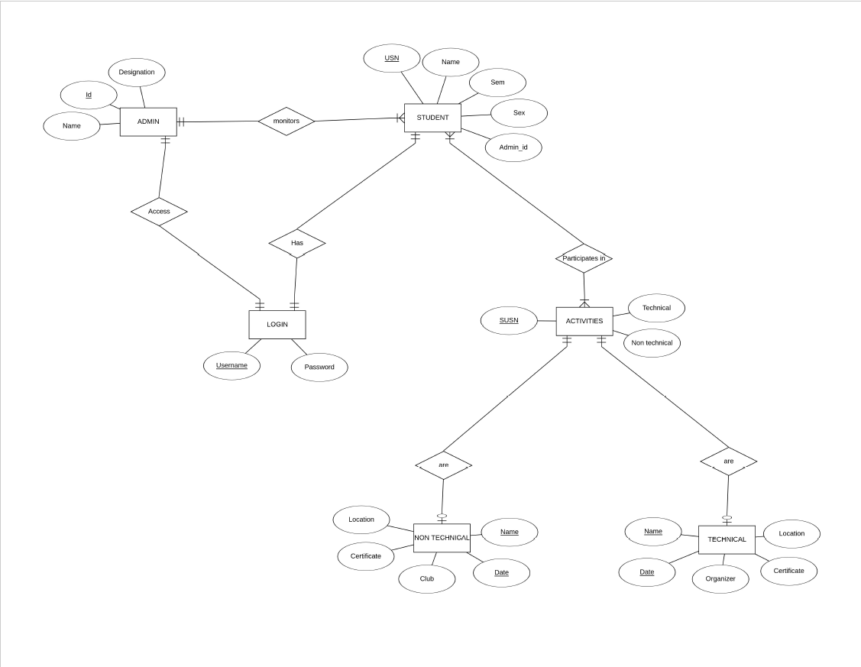

**RELATIONAL DATABASE DESIGN**

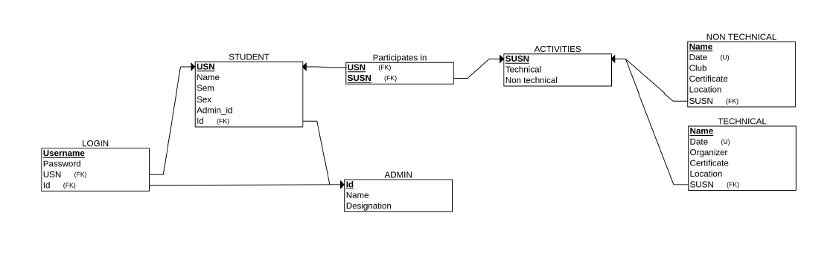

**DATABASE DIRECTORY**

**Table structure for table `activities`:**

CREATE TABLE `activities` (

`acname` varchar(50) NOT NULL,

`location` varchar(50) NOT NULL,

`certificate` int(11) NOT NULL

) ;

**Table structure for table `admin`:**

CREATE TABLE `admin` (

`id` varchar(50) NOT NULL,

`fname` varchar(50) NOT NULL,

`lname` varchar(50) NOT NULL,

`sex` varchar(50) NOT NULL,

`designation` varchar(50) NOT NULL,

`mobile` varchar(50) NOT NULL,

`email` varchar(50) NOT NULL

);

**Table structure for table `student`:**

CREATE TABLE `student` (

`usn` varchar(50) NOT NULL,

`fname` varchar(50) NOT NULL,

`lname` varchar(50) NOT NULL,

`sem` int(11) NOT NULL,

`sex` varchar(50) NOT NULL,

`pid` varchar(50) NOT NULL,

`mobile` varchar(50) NOT NULL,

`email` varchar(50) NOT NULL

);

**Table structure for table `alogin`:**

CREATE TABLE `alogin` (

`id` varchar(50) NOT NULL,

`password` varchar(50) NOT NULL

);

**Table structure for table `slogin`:**

CREATE TABLE `slogin` (

`usn` varchar(50) NOT NULL,

`password` varchar(50) NOT NULL

);

**Table structure for table `nontechnical`:**

CREATE TABLE `nontechnical` (

`acname` varchar(50) NOT NULL,

`club` varchar(50) NOT NULL

);

**Table structure for table `technical`:**

CREATE TABLE `technical` (

`acname` varchar(50) NOT NULL,

`organizer` varchar(50) NOT NULL

);

**Table structure for table `participate`:**

CREATE TABLE `participate` (

`usn` varchar(50) NOT NULL,

`acname` varchar(50) NOT NULL,

`date` varchar(50) NOT NULL

);

ALTER TABLE `activities`

ADD PRIMARY KEY (`acname`);

ALTER TABLE `admin`

ADD PRIMARY KEY (`id`);

ALTER TABLE `alogin`

ADD KEY `id` (`id`);

ALTER TABLE `nontechnical`

ADD KEY `nontechnical_ibfk_1` (`acname`);

ALTER TABLE `participate`

ADD PRIMARY KEY (`usn`) USING BTREE,

ADD KEY `acname` (`acname`);

ALTER TABLE `slogin`

ADD KEY `slogin_ibfk_1` (`usn`);

ALTER TABLE `student`

ADD PRIMARY KEY (`usn`);

ALTER TABLE `technical`

ADD KEY `acname` (`acname`);

ALTER TABLE `alogin`

ADD CONSTRAINT `alogin_ibfk_1` FOREIGN KEY (`id`) REFERENCES `admin` (`id`) ON DELETE CASCADE ON UPDATE CASCADE;

ALTER TABLE `nontechnical`

ADD CONSTRAINT `nontechnical_ibfk_1` FOREIGN KEY (`acname`) REFERENCES `activities` (`acname`) ON DELETE CASCADE ON UPDATE CASCADE;

ALTER TABLE `participate`

ADD CONSTRAINT `participate_ibfk_1` FOREIGN KEY (`usn`) REFERENCES `student` (`usn`),

ADD CONSTRAINT `participate_ibfk_2` FOREIGN KEY (`acname`) REFERENCES `activities` (`acname`);

ALTER TABLE `slogin`

ADD CONSTRAINT `slogin_ibfk_1` FOREIGN KEY (`usn`) REFERENCES `student` (`usn`) ON DELETE CASCADE ON UPDATE CASCADE;

ALTER TABLE `technical`

ADD CONSTRAINT `technical_ibfk_1` FOREIGN KEY (`acname`) REFERENCES `activities` (`acname`),

COMMIT;

**GRAPHICAL USER INTERFACE**

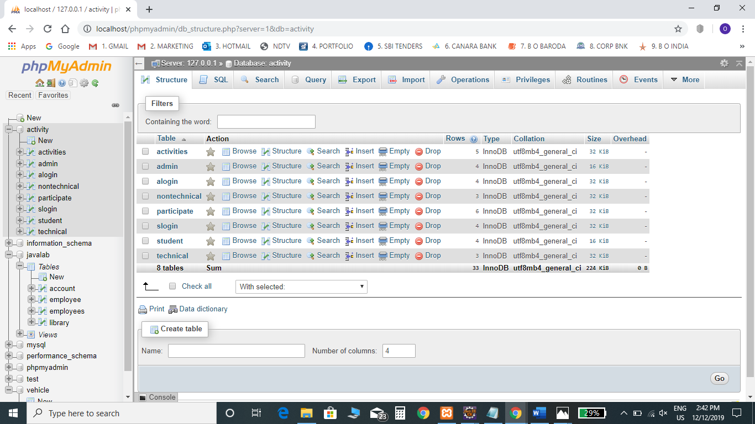

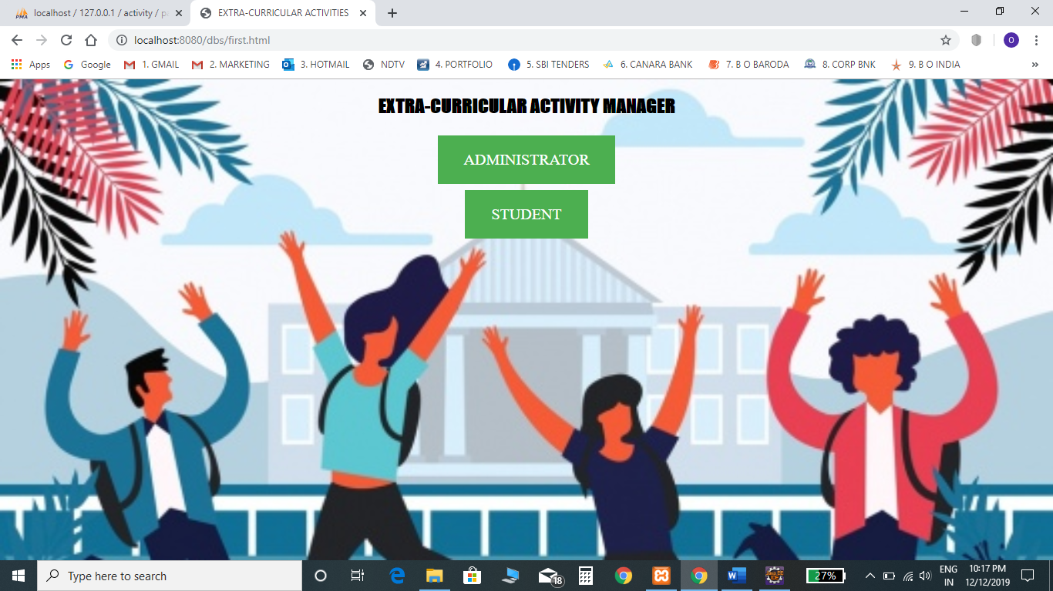

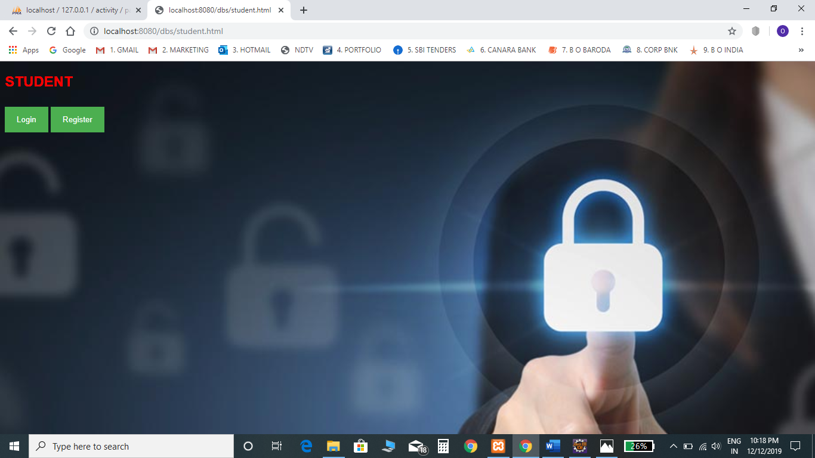

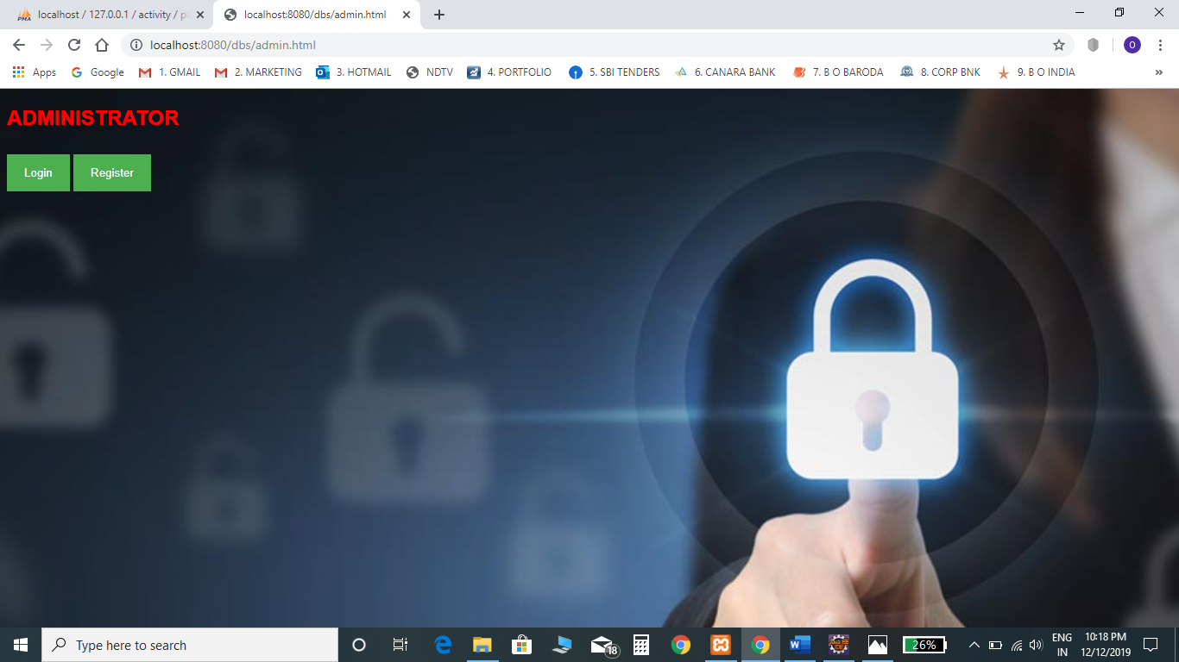

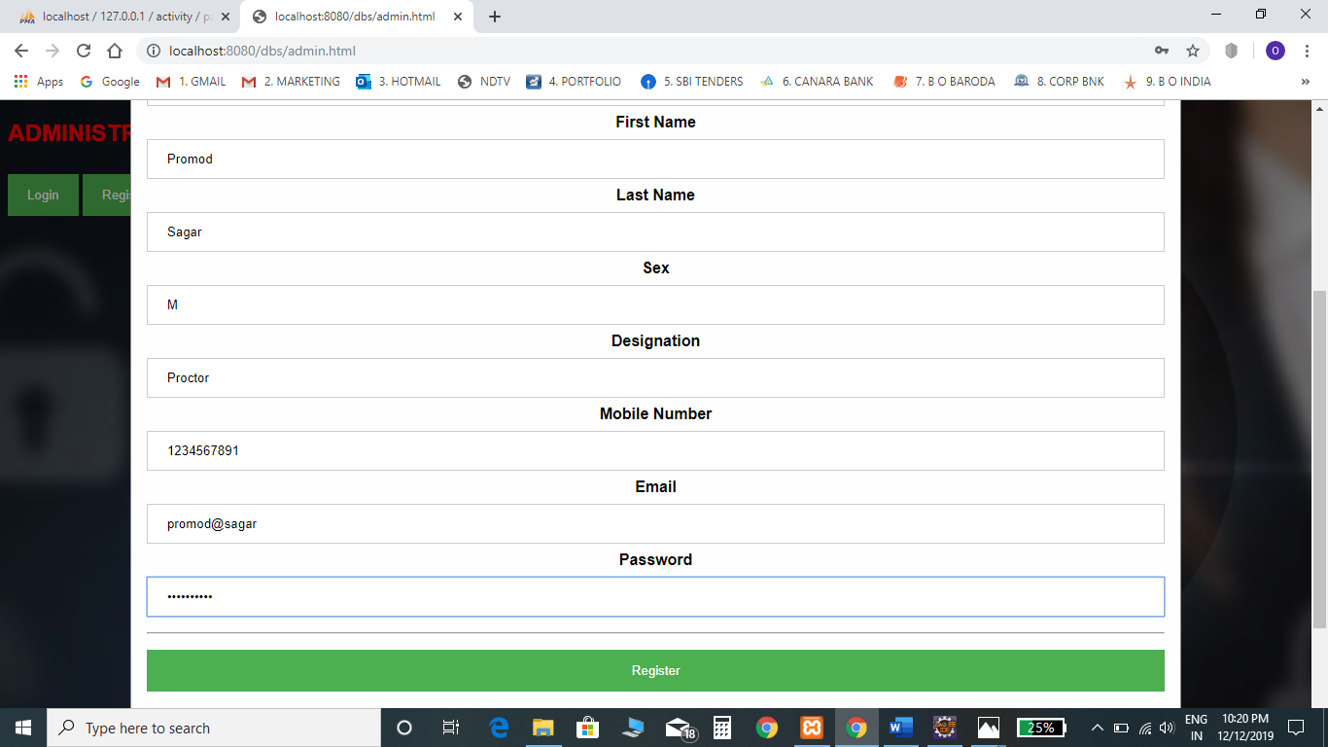

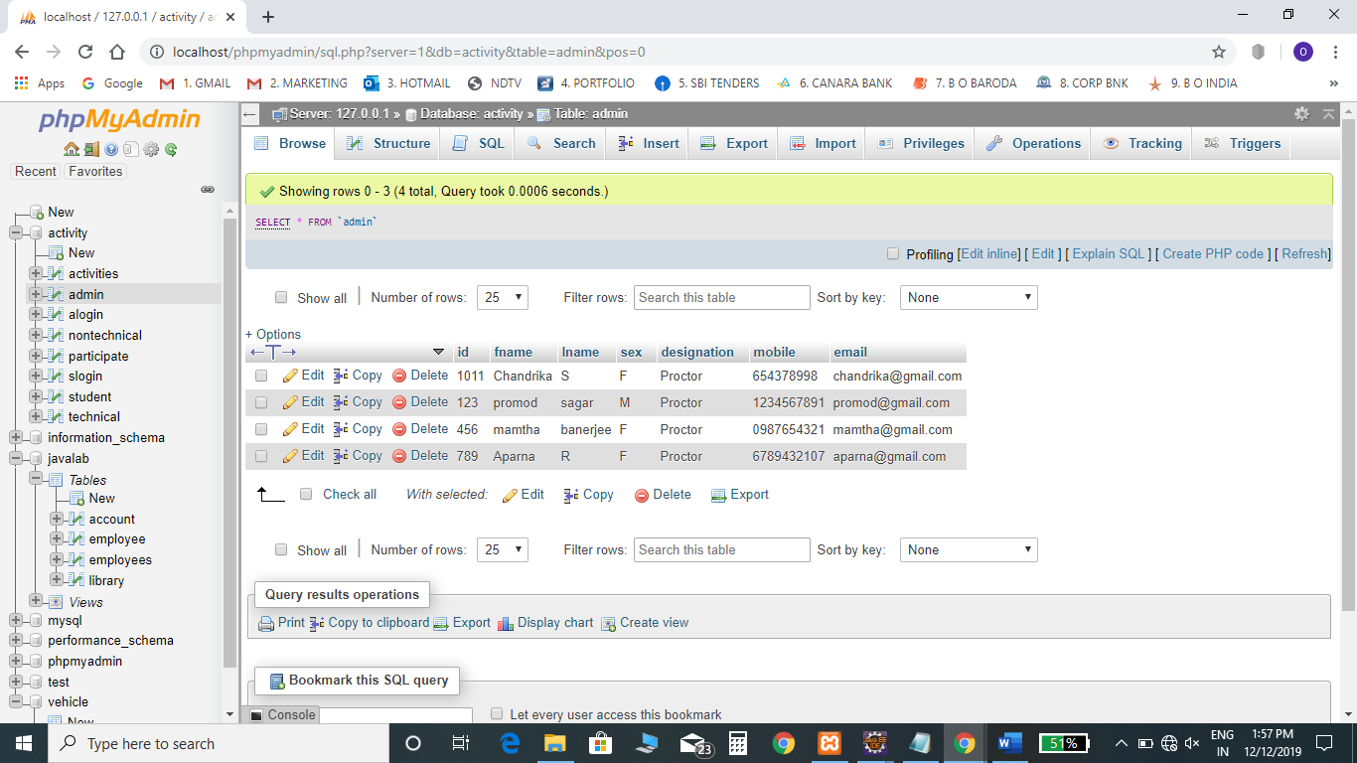

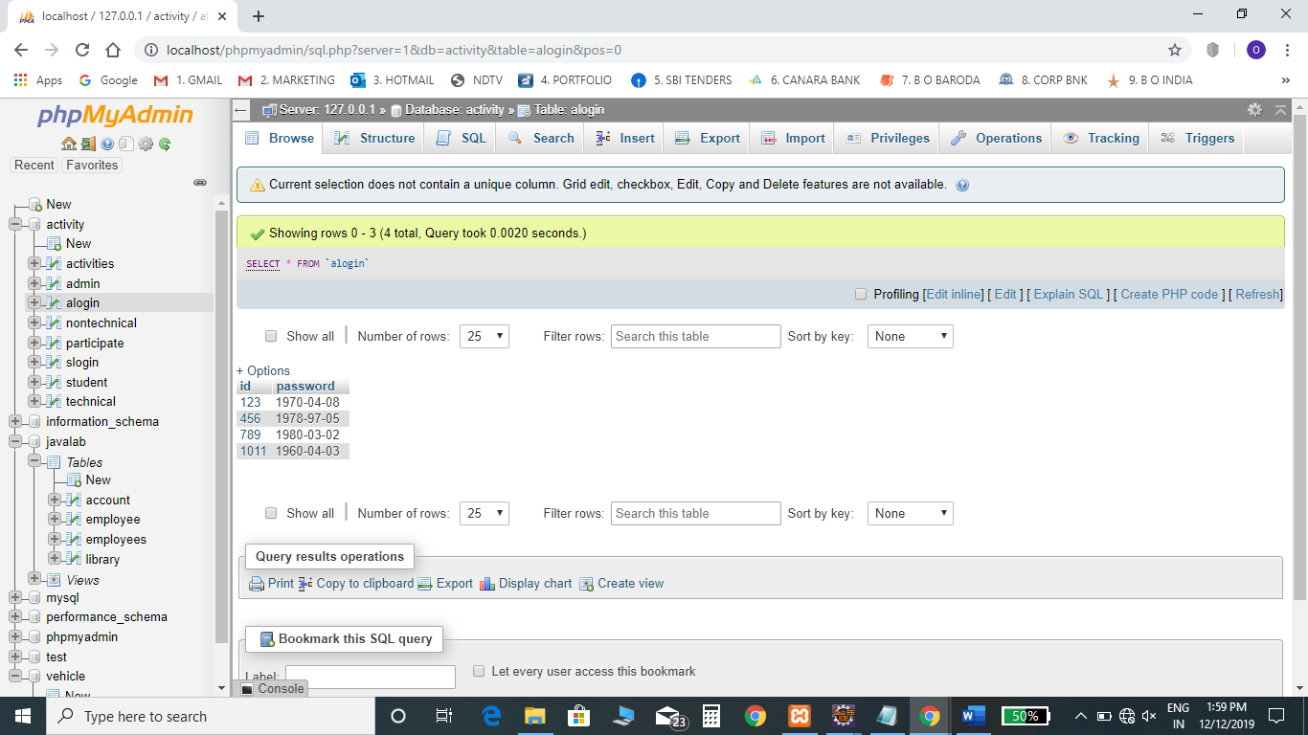

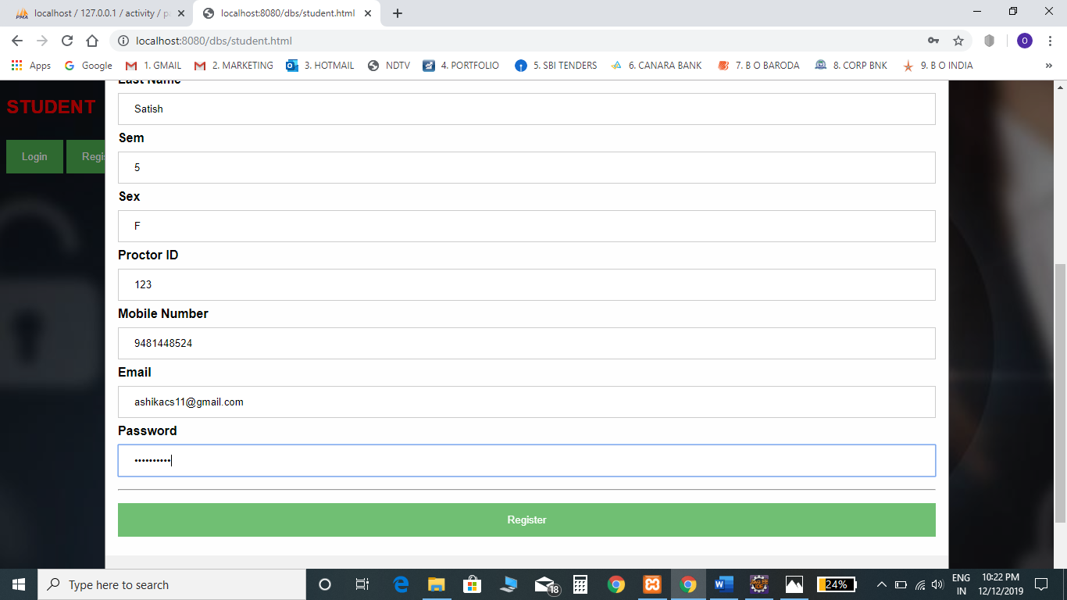

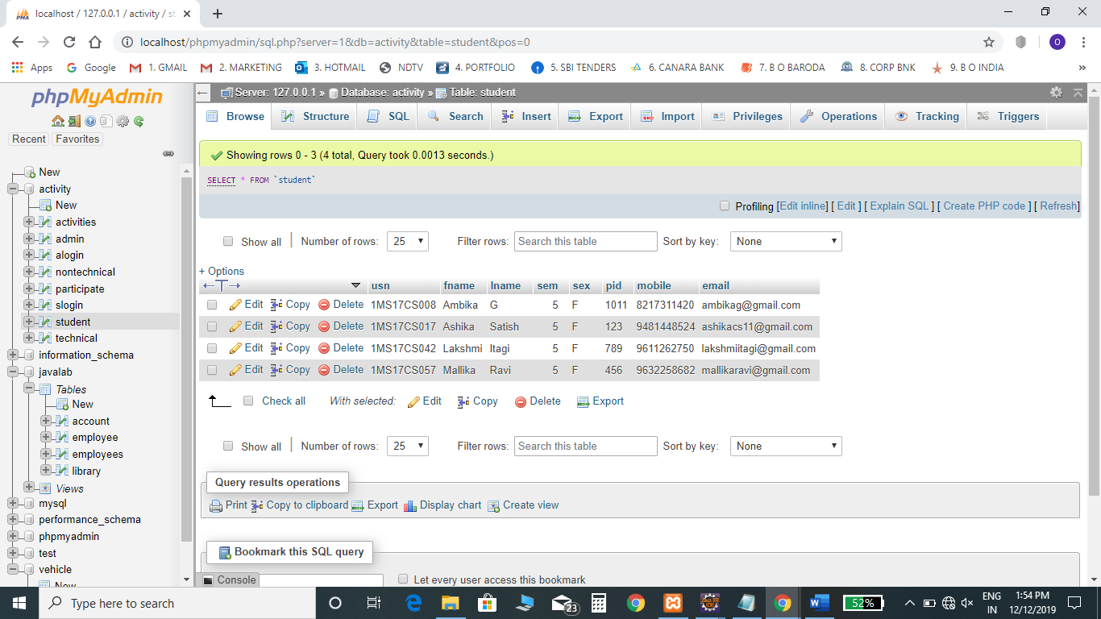

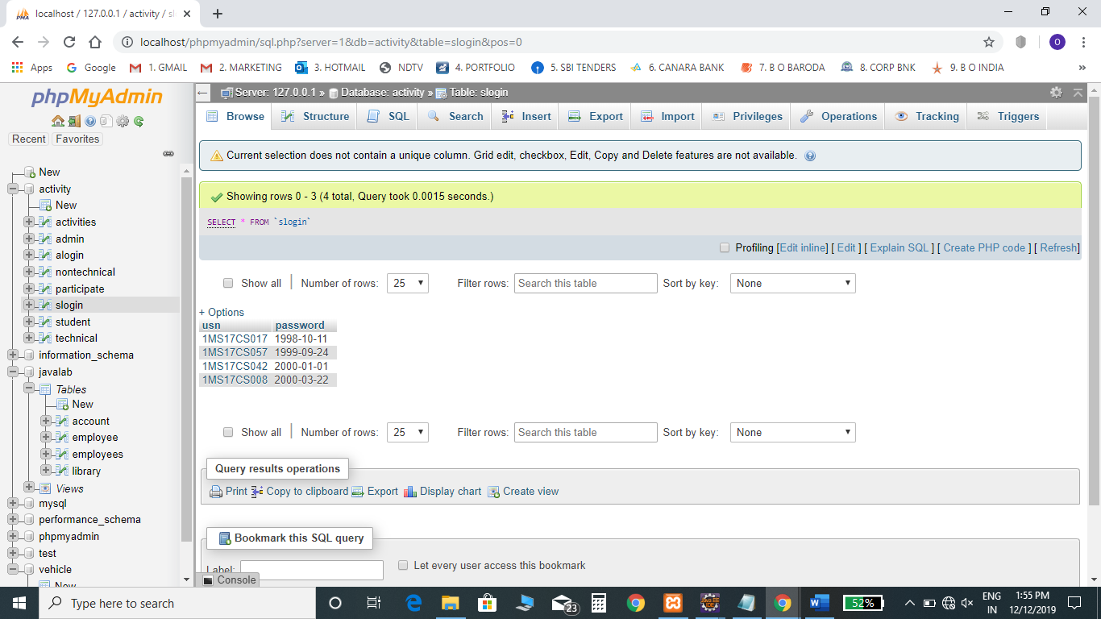

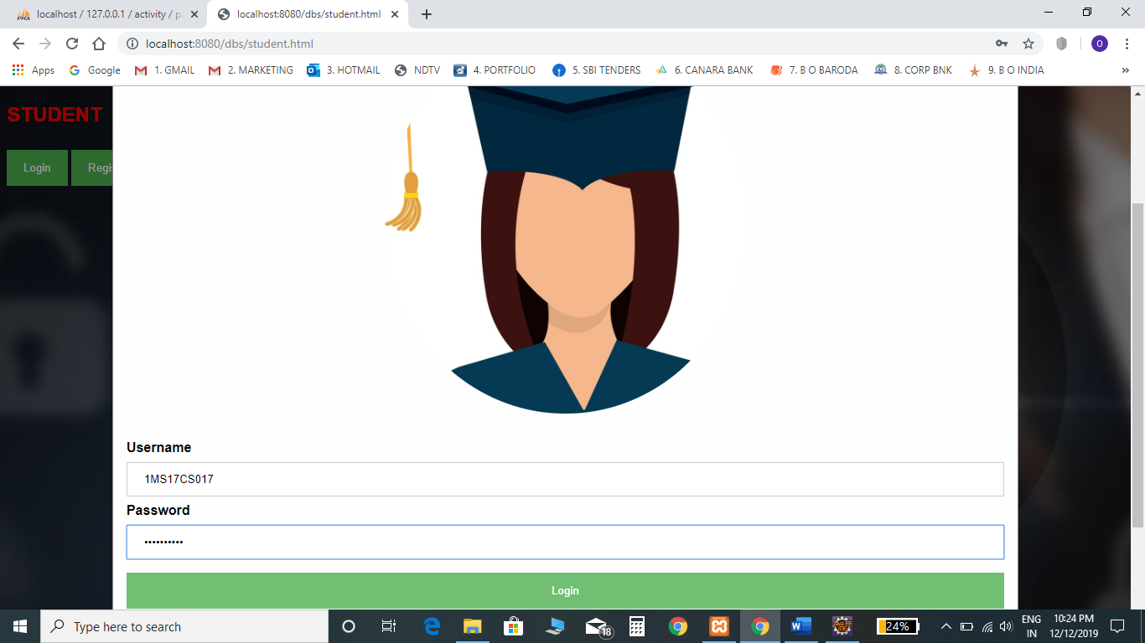

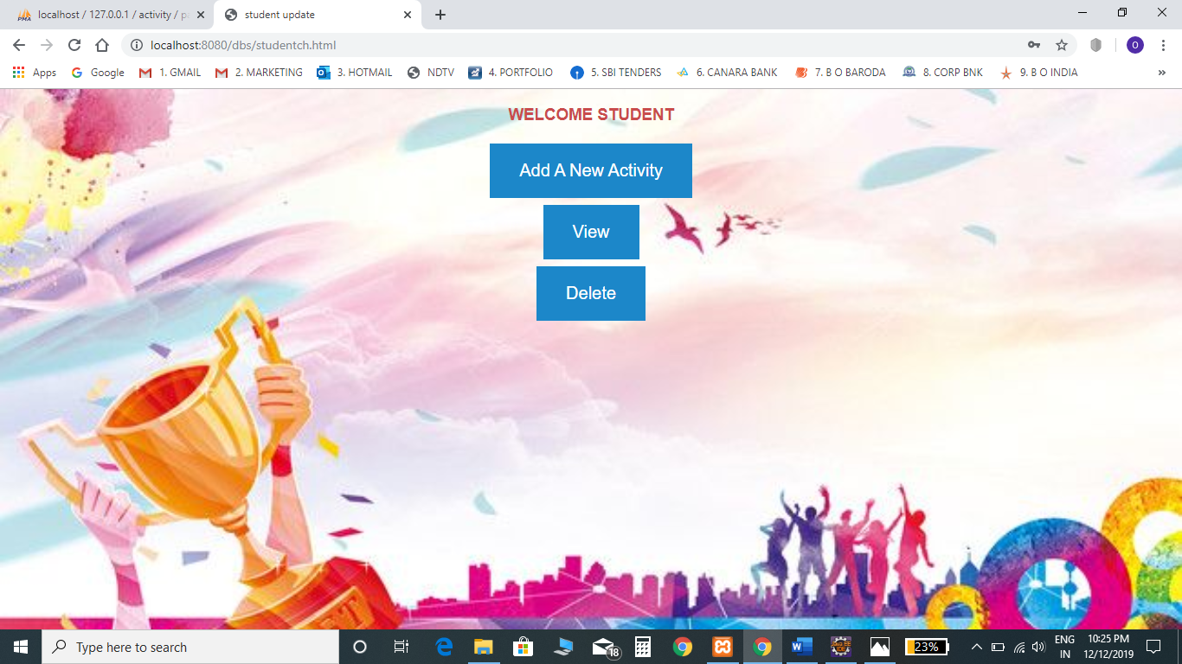

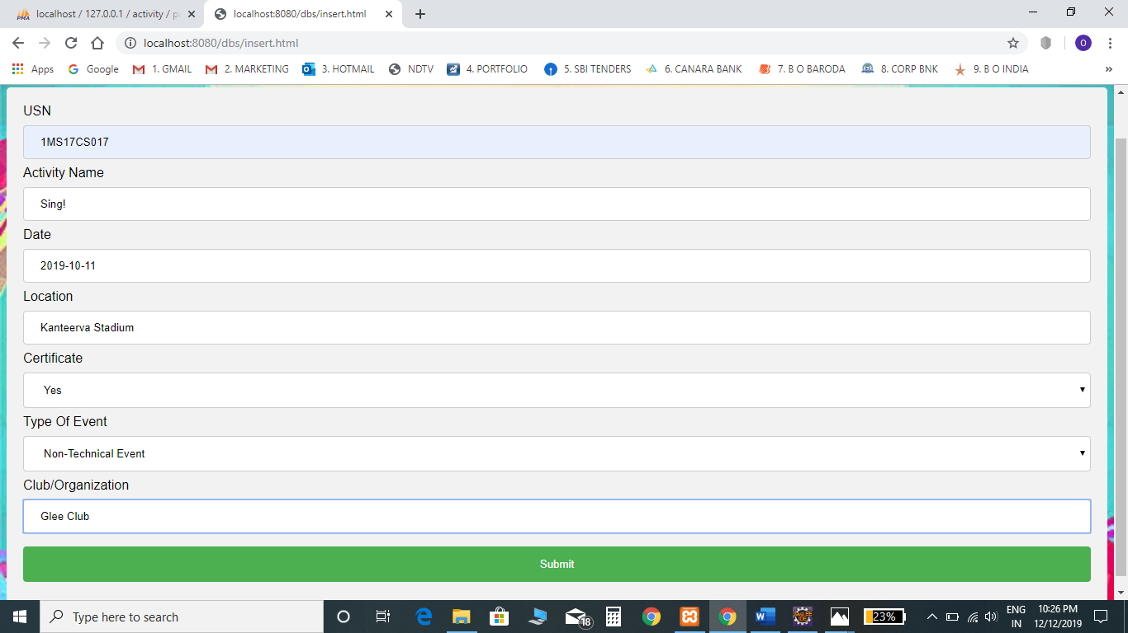

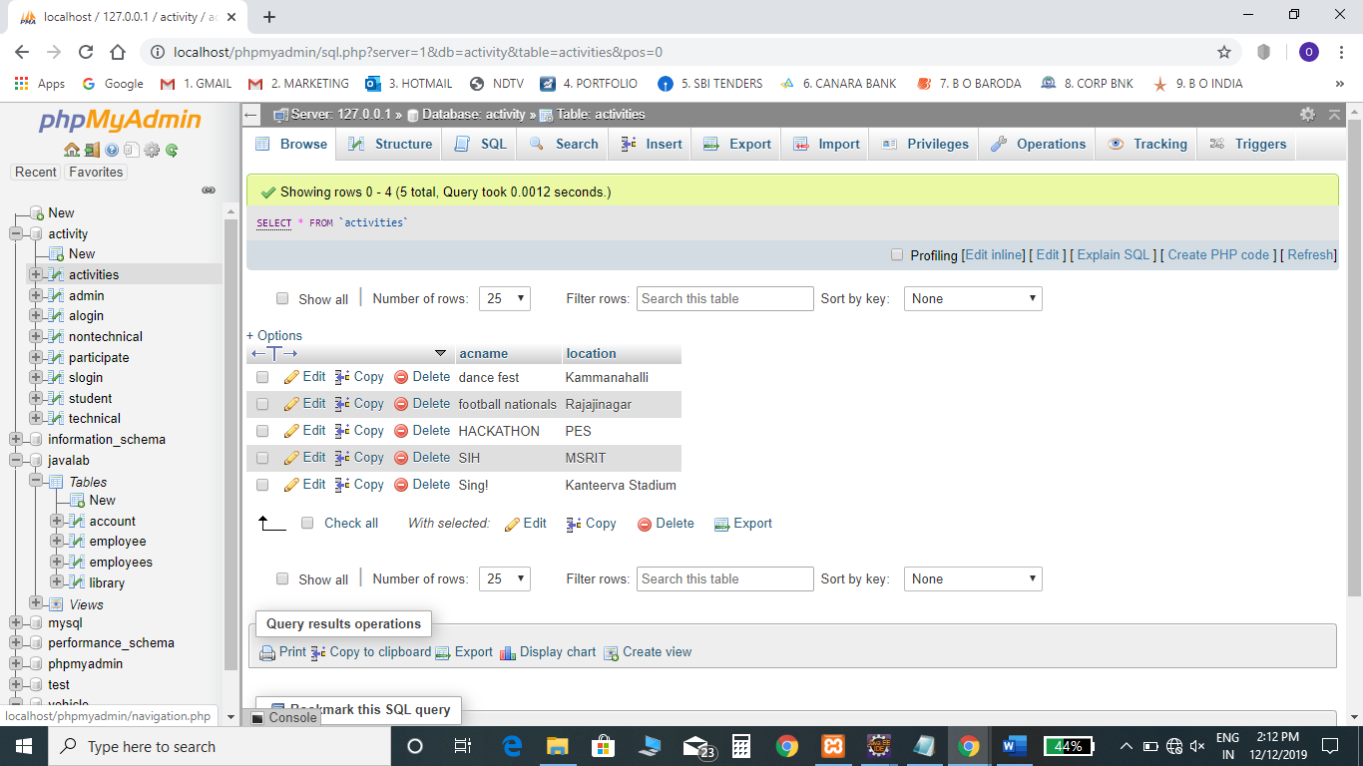

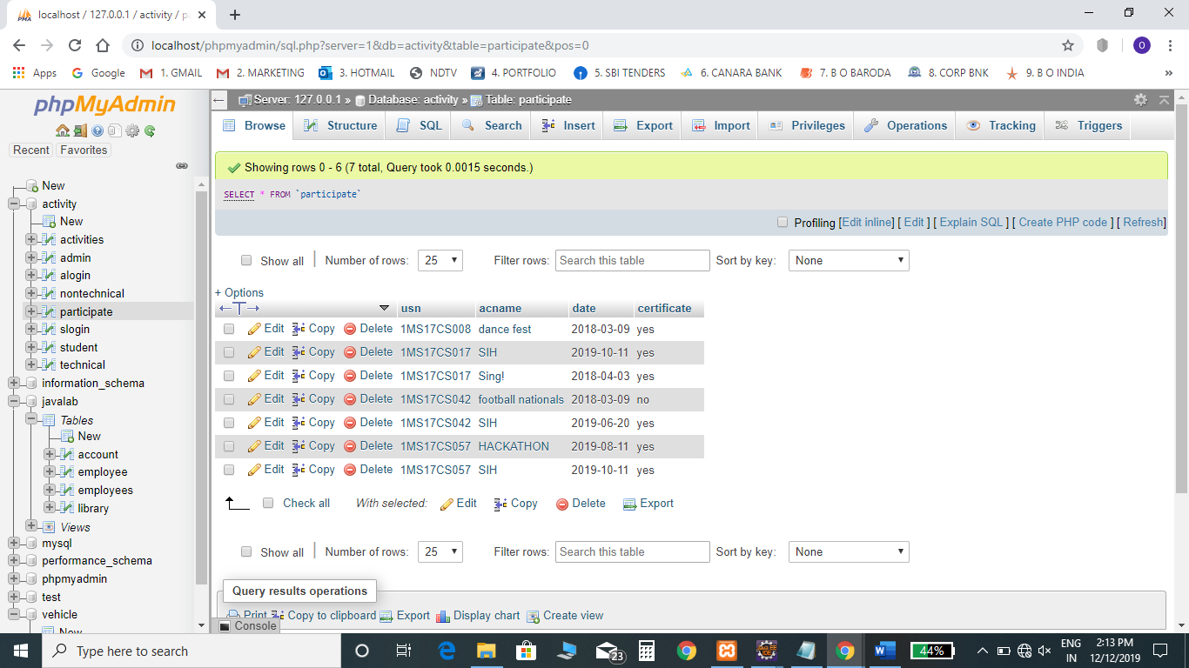

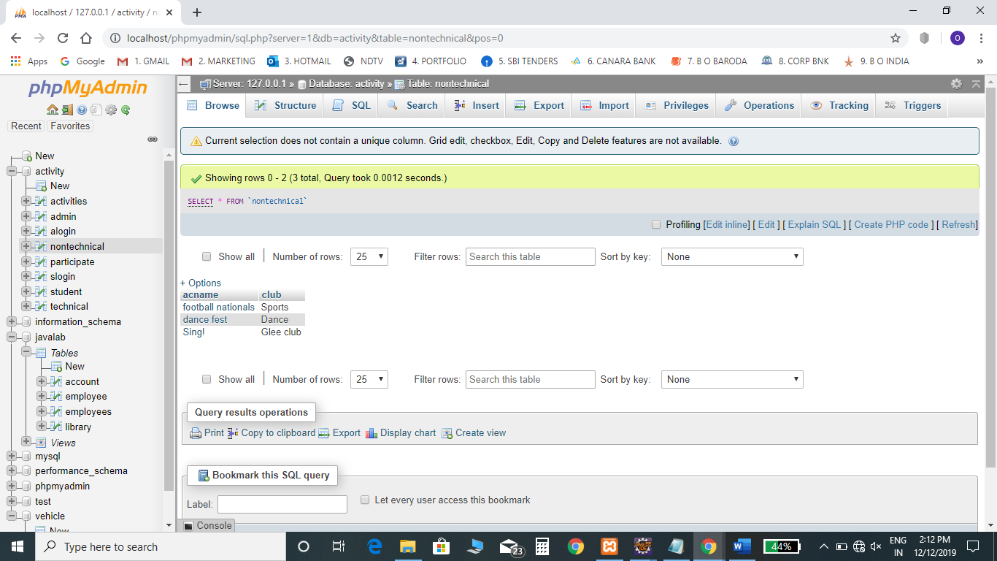

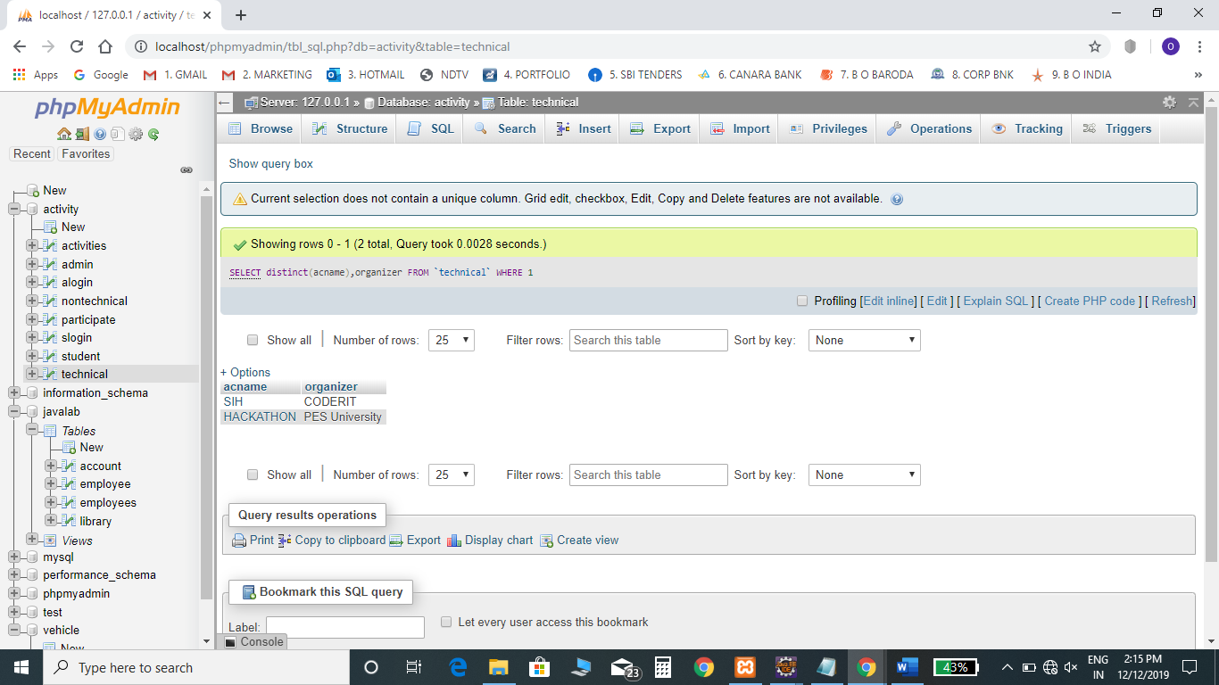

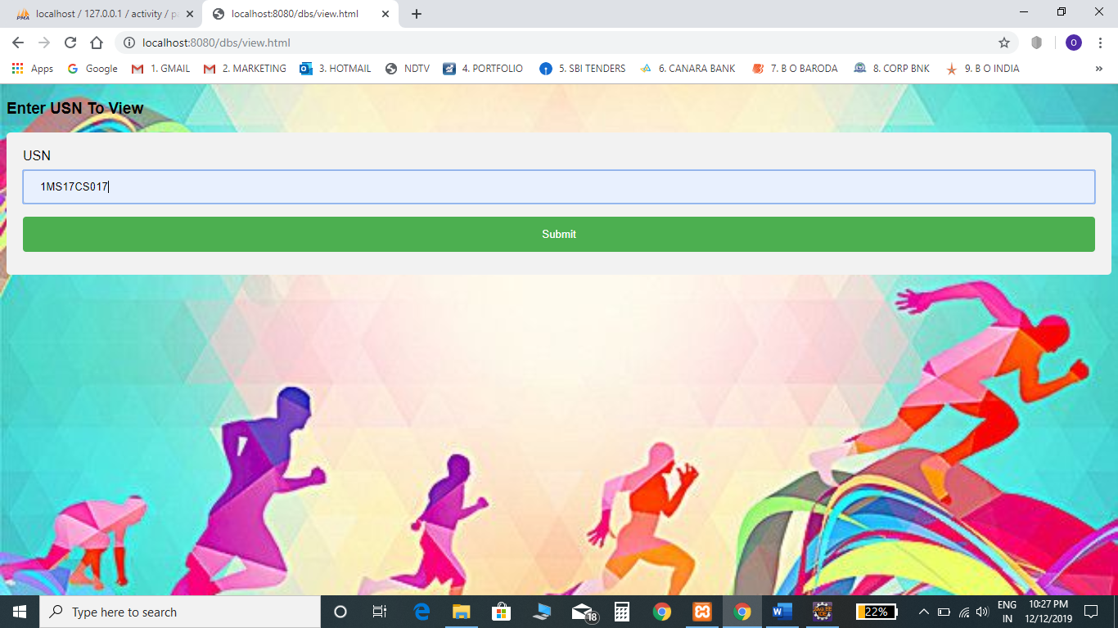

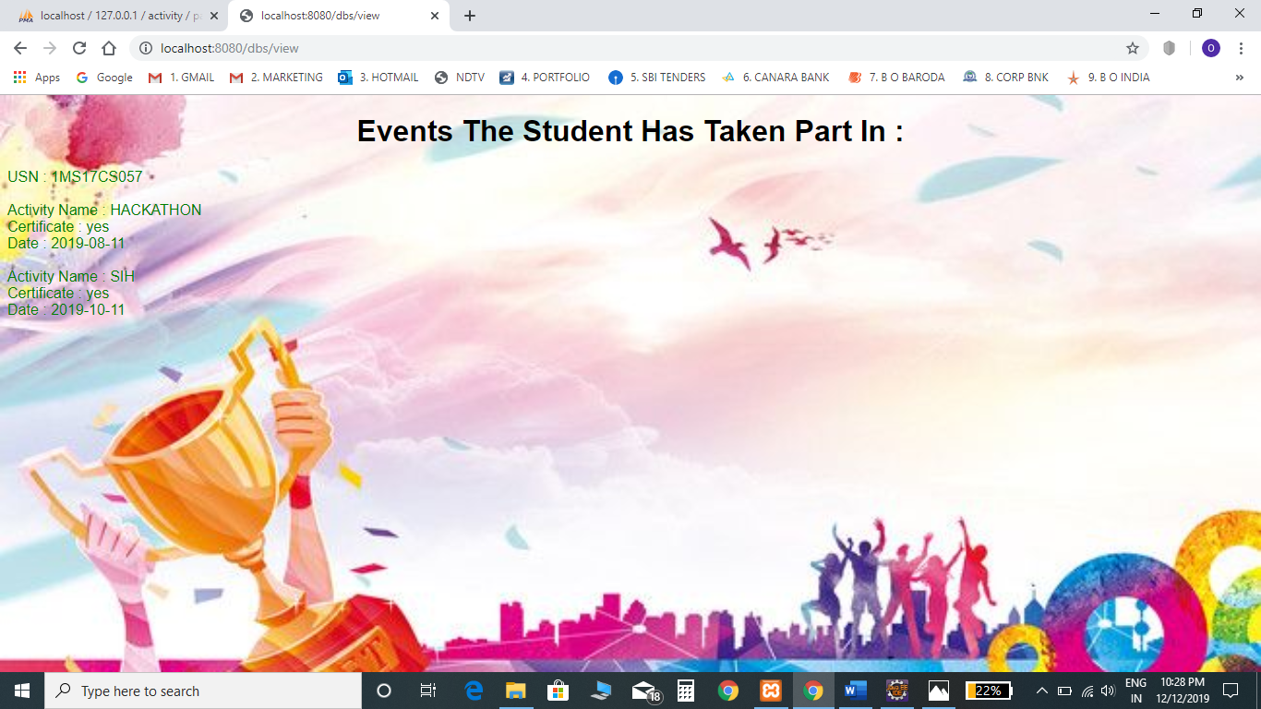

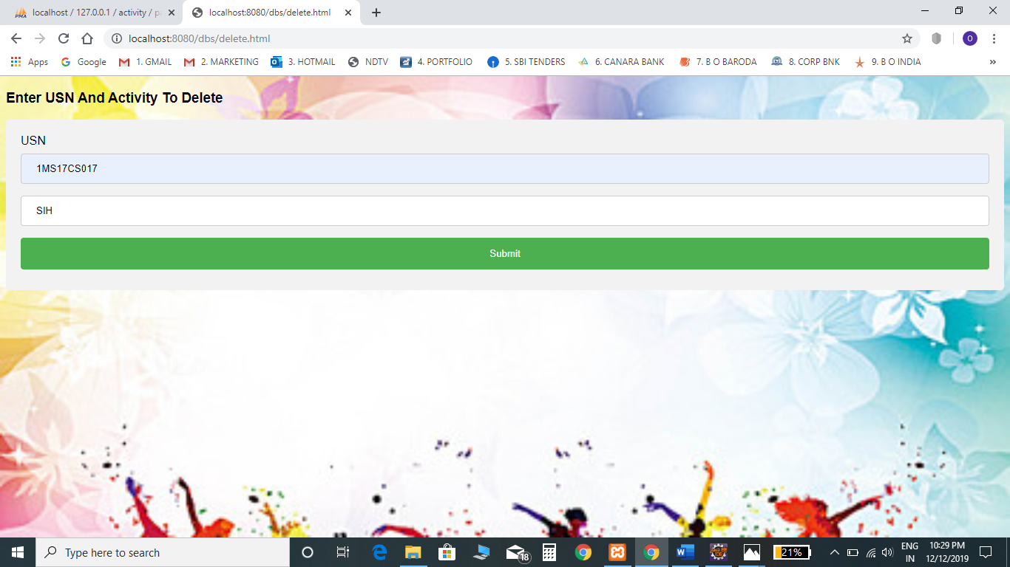

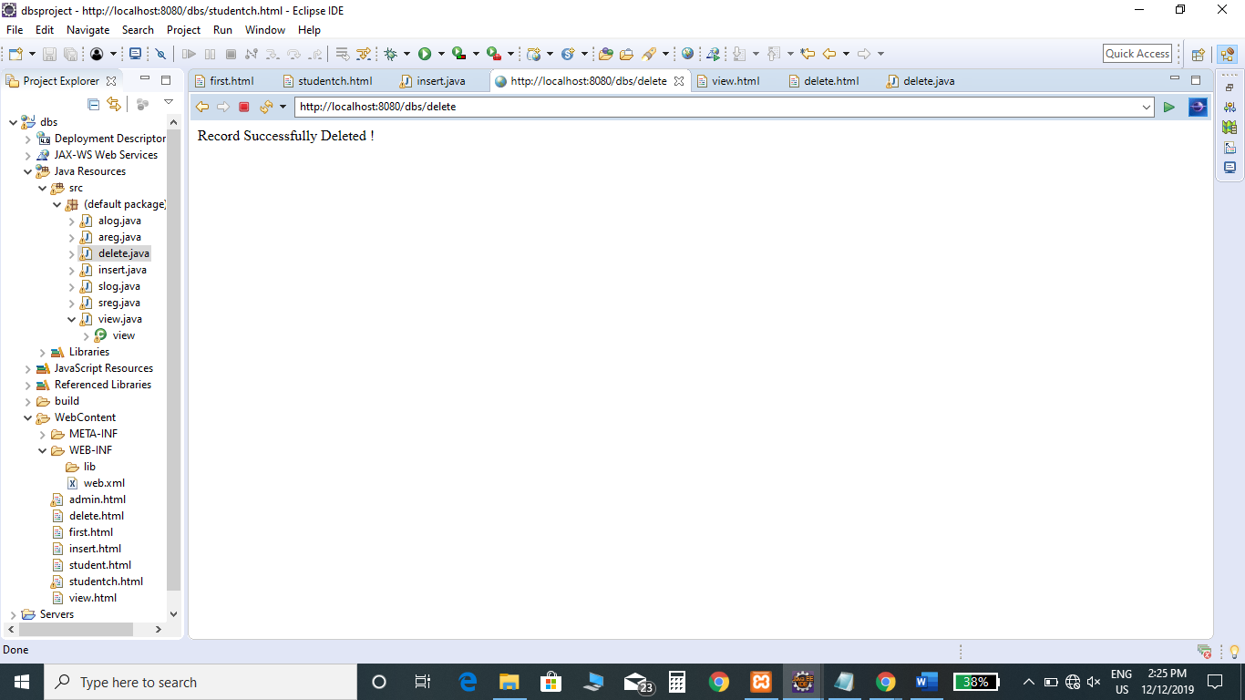

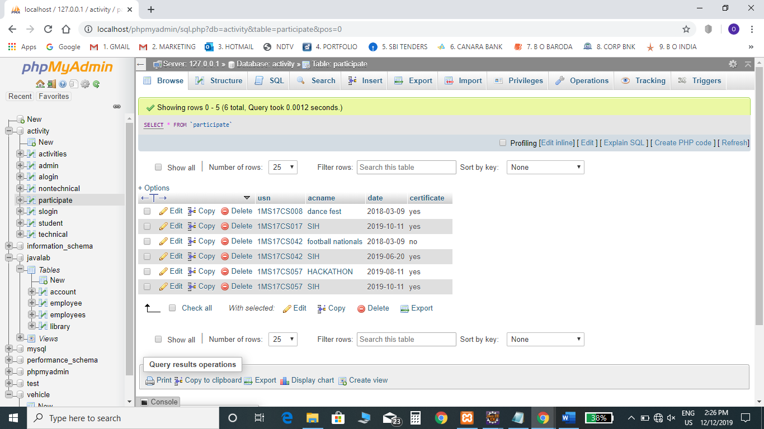

**SOURCE CODE**

**welcome.html**

<!DOCTYPE html>

<html>

<head>

<title>EXTRA-CURRICULAR ACTIVITIES</title>

<style>

*.button* {

background-color: *#1c87c9*;

border: *none*;

color: *white*;

padding: *20px 34px*;

text-align: *center*;

text-decoration: *none*;

display: *inline-block*;

font-size: *20px*;

margin: *4px 2px*;

cursor: *pointer*;

}

</style>

</head>

<body>

<h2>EXTRA-CURRICULAR ACTIVITY MANAGER</h2>

<a href=*"admin.html"* class=*"button"*>ADMINISTRATOR</a>

<a href=*"student.html"* class=*"button"*>STUDENT</a>

</body>

</html>

**student.html**

<!DOCTYPE html>

<html>

<head>

<meta name=*"viewport"* content=*"width=device-width, initial-scale=1"*>

<style>

**body** {font-family: *Arial, Helvetica, sans-serif*;}

/* Full-width input fields */

**input**[type=text]**,** **input**[type=password] {

width: *100%*;

padding: *12px 20px*;

margin: *8px 0*;

display: *inline-block*;

border: *1px solid #ccc*;

box-sizing: *border-box*;

}

/* Set a style for all buttons */

**button** {

background-color: *#4CAF50*;

color: *white*;

padding: *14px 20px*;

margin: *8px 0*;

border: *none*;

cursor: *pointer*;

width: *100%*;

}

**button***:hover* {

opacity: *0.8*;

}

/* Extra styles for the cancel button */

*.cancelbtn* {

width: *auto*;

padding: *10px 18px*;

background-color: *#f44336*;

}

/* Center the image and position the close button */

*.imgcontainer* {

text-align: *center*;

margin: *24px 0 12px 0*;

position: *relative*;

}

**img***.avatar* {

width: *40%*;

border-radius: *50%*;

}

*.container* {

padding: *16px*;

}

**span***.psw* {

float: *right*;

padding-top: *16px*;

}

/* The Modal (background) */

*.modal* {

display: *none*; /* Hidden by default */

position: *fixed*; /* Stay in place */

z-index: *1*; /* Sit on top */

left: *0*;

top: *0*;

width: *100%*; /* Full width */

height: *100%*; /* Full height */

overflow: *auto*; /* Enable scroll if needed */

background-color: *rgb(0,0,0)*; /* Fallback color */

background-color: *rgba(0,0,0,0.4)*; /* Black w/ opacity */

padding-top: *60px*;

}

/* Modal Content/Box */

*.modal-content* {

background-color: *#fefefe*;

margin: *5% auto 15% auto*; /* 5% from the top, 15% from the bottom and centered */

border: *1px solid #888*;

width: *80%*; /* Could be more or less, depending on screen size */

}

/* The Close Button (x) */

*.close* {

position: *absolute*;

right: *25px*;

top: *0*;

color: *#000*;

font-size: *35px*;

font-weight: *bold*;

}

*.close:hover***,**

*.close:focus* {

color: *red*;

cursor: *pointer*;

}

/* Add Zoom Animation */

*.animate* {

-webkit-animation: *animatezoom 0.6s*;

animation: *animatezoom 0.6s*

}

@**-webkit-keyframes** **animatezoom** {

from {-webkit-transform: *scale(0)*}

**to** {-webkit-transform: *scale(1)*}

}

@**keyframes** **animatezoom** {

from {transform: *scale(0)*}

**to** {transform: *scale(1)*}

}

/* Change styles for span and cancel button on extra small screens */

@media screen and (max-width: 300px) {

**span***.psw* {

display: *block*;

float: *none*;

}

*.cancelbtn* {

width: *100%*;

}

}

</style>

</head>

<body>

<h2>STUDENT</h2>

<button onclick="document.getElementById('id01').style.display='block'" style="width:*auto*;">Login</button>

<div id=*"id01"* class=*"modal"*>

<form class=*"modal-content animate"* action=*"slog"* method=*"post"*>

<div class=*"imgcontainer"*>

<span onclick="document.getElementById('id01').style.display='none'" class=*"close"* title=*"Close Modal"*>&times;</span>

<img src=*"C:\Users\cvsat\eclipse-workspace\dbsproject\dbs\WebContent\WEB-INF\img_avatar2.png"* alt=*"Avatar"* class=*"avatar"*>

</div>

<div class=*"container"*>

<label for=*"uname"*><b>Username</b></label>

<input type=*"text"* placeholder=*"Enter USN"* name=*"usn"* required>

<label for=*"psw"*><b>Password</b></label>

<input type=*"password"* placeholder=*"YYYY-MM-DD"* name=*"psw"* required>

<button type=*"submit"*>Login</button>

</div>

<div class=*"container"* style="background-color:*#f1f1f1*">

<button type=*"button"* onclick="document.getElementById('id01').style.display='none'" class=*"cancelbtn"*>Cancel</button>

</div>

</form>

</div>

<button onclick="document.getElementById('id02').style.display='block'" style="width:*auto*;">Register</button>

<div id=*"id02"* class=*"modal"*>

<form class=*"modal-content animate"* action=*"sreg"* method=*"post"*>

<div class=*"imgcontainer"*>

<span onclick="document.getElementById('id02').style.display='none'" class=*"close"* title=*"Close Modal"*>&times;</span>

</div>

<div class=*"container"*>

<h1>Register</h1>

<p>Please fill in this form to create an account.</p>

<hr>

<label for=*""*><b>USN</b></label>

<input type=*"text"* placeholder=*"eg : 1MS17CS017"* name=*"usn"* required>

<label for=*""*><b>First Name</b></label>

<input type=*"text"* placeholder=*"eg : Mike"* name=*"fname"* required>

<label for=*""*><b>Last Name</b></label>

<input type=*"text"* placeholder=*"eg : Hannigan"* name=*"lname"* required>

<label for=*""*><b>Sem</b></label>

<input type=*"text"* placeholder=*"Enter Sem"* name=*"sem"* required>

<label for=*""*><b>Sex</b></label>

<input type=*"text"* placeholder=*"Enter F or M"* name=*"sex"* required>

<label for=*""*><b>Proctor ID</b></label>

<input type=*"text"* placeholder=*"Enter proctor id"* name=*"id"* required>

<label for=*""*><b>Mobile Number</b></label>

<input type=*"text"* placeholder=*"Enter mobile number"* name=*"num"* required>

<label for=*"email"*><b>Email</b></label>

<input type=*"text"* placeholder=*"Enter Email"* name=*"email"* required>

<label for=*"psw"*><b>Password</b></label>

<input type=*"password"* placeholder=*"Enter date of birth eg : YYYY-MM-DD "* name=*"psw"* required>

<hr>

<button type=*"submit"* class=*"registerbtn"*>Register</button>

</div>

<div class=*"container"* style="background-color:*#f1f1f1*">

<button type=*"button"* onclick="document.getElementById('id02').style.display='none'" class=*"cancelbtn"*>Cancel</button>

</div>

</form>

</div>

<script>

// Get the modal

**var** modal = document.getElementById('id01','id02');

// When the user clicks anywhere outside of the modal, close it

window.onclick = **function**(event) {

**if** (event.target == modal) {

modal.style.display = "none";

}

}

</script>

</body>

</html>

**admin.html**

<!DOCTYPE html>

<html>

<head>

<meta name=*"viewport"* content=*"width=device-width, initial-scale=1"*>

<style>

**body** {font-family: *Arial, Helvetica, sans-serif*;}

/* Full-width input fields */

**input**[type=text]**,** **input**[type=password] {

width: *100%*;

padding: *12px 20px*;

margin: *8px 0*;

display: *inline-block*;

border: *1px solid #ccc*;

box-sizing: *border-box*;

}

/* Set a style for all buttons */

**button** {

background-color: *#4CAF50*;

color: *white*;

padding: *14px 20px*;

margin: *8px 0*;

border: *none*;

cursor: *pointer*;

width: *100%*;

}

**button***:hover* {

opacity: *0.8*;

}

/* Extra styles for the cancel button */

*.cancelbtn* {

width: *auto*;

padding: *10px 18px*;

background-color: *#f44336*;

}

/* Center the image and position the close button */

*.imgcontainer* {

text-align: *center*;

margin: *24px 0 12px 0*;

position: *relative*;

}

**img***.avatar* {

width: *40%*;

border-radius: *50%*;

}

*.container* {

padding: *16px*;

}

**span***.psw* {

float: *right*;

padding-top: *16px*;

}

/* The Modal (background) */

*.modal* {

display: *none*; /* Hidden by default */

position: *fixed*; /* Stay in place */

z-index: *1*; /* Sit on top */

left: *0*;

top: *0*;

width: *100%*; /* Full width */

height: *100%*; /* Full height */

overflow: *auto*; /* Enable scroll if needed */

background-color: *rgb(0,0,0)*; /* Fallback color */

background-color: *rgba(0,0,0,0.4)*; /* Black w/ opacity */

padding-top: *60px*;

}

/* Modal Content/Box */

*.modal-content* {

background-color: *#fefefe*;

margin: *5% auto 15% auto*; /* 5% from the top, 15% from the bottom and centered */

border: *1px solid #888*;

width: *80%*; /* Could be more or less, depending on screen size */

}

/* The Close Button (x) */

*.close* {

position: *absolute*;

right: *25px*;

top: *0*;

color: *#000*;

font-size: *35px*;

font-weight: *bold*;

}

*.close:hover***,**

*.close:focus* {

color: *red*;

cursor: *pointer*;

}

/* Add Zoom Animation */

*.animate* {

-webkit-animation: *animatezoom 0.6s*;

animation: *animatezoom 0.6s*

}

@**-webkit-keyframes** **animatezoom** {

from {-webkit-transform: *scale(0)*}

**to** {-webkit-transform: *scale(1)*}

}

@**keyframes** **animatezoom** {

from {transform: *scale(0)*}

**to** {transform: *scale(1)*}

}

/* Change styles for span and cancel button on extra small screens */

@media screen and (max-width: 300px) {

**span***.psw* {

display: *block*;

float: *none*;

}

*.cancelbtn* {

width: *100%*;

}

}

</style>

</head>

<body>

<h2>ADMINISTRATOR</h2>

<button onclick="document.getElementById('id01').style.display='block'" style="width:*auto*;">Login</button>

<div id=*"id01"* class=*"modal"*>

<form class=*"modal-content animate"* action=*"alog"* method=*"post"*>

<div class=*"imgcontainer"*>

<span onclick="document.getElementById('id01').style.display='none'" class=*"close"* title=*"Close Modal"*>&times;</span>

<img src=*"C:\Users\cvsat\eclipse-workspace\dbsproject\dbs\WebContent\META-INF\img_avatar2.jpg"* alt=*"Avatar"* class=*"avatar"*>

</div>

<div class=*"container"*>

<label for=*"uname"*><b>Username</b></label>

<input type=*"text"* placeholder=*"Enter ID"* name=*"id"* required>

<label for=*"psw"*><b>Password</b></label>

<input type=*"password"* placeholder=*"YYYY-MM-DD"* name=*"psw"* required>

<button type=*"submit"*>Login</button>

</div>

<div class=*"container"* style="background-color:*#f1f1f1*">

<button type=*"button"* onclick="document.getElementById('id01').style.display='none'" class=*"cancelbtn"*>Cancel</button>

</div>

</form>

</div>

<button onclick="document.getElementById('id02').style.display='block'" style="width:*auto*;">Register</button>

<div id=*"id02"* class=*"modal"*>

<form class=*"modal-content animate"* action=*"areg"* method=*"post"*>

<div class=*"imgcontainer"*>

<span onclick="document.getElementById('id02').style.display='none'" class=*"close"* title=*"Close Modal"*>&times;</span>

<div class=*"container"*>

<h1>Register</h1>

<p>Please fill in this form to create an account.</p>

<hr>

<label for=*""*><b>ID</b></label>

<input type=*"text"* placeholder=*"eg : 1MS17CS017"* name=*"id"* required>

<label for=*""*><b>First Name</b></label>

<input type=*"text"* placeholder=*"eg : Mike"* name=*"fname"* required>

<label for=*""*><b>Last Name</b></label>

<input type=*"text"* placeholder=*"eg : Hannigan"* name=*"lname"* required>

<label for=*""*><b>Sex</b></label>

<input type=*"text"* placeholder=*"Enter F or M "* name=*"sex"* required>

<label for=*""*><b>Designation</b></label>

<input type=*"text"* placeholder=*"Enter designation"* name=*"des"* required>

<label for=*""*><b>Mobile Number</b></label>

<input type=*"text"* placeholder=*"Enter mobile number"* name=*"num"* required>

<label for=*"email"*><b>Email</b></label>

<input type=*"text"* placeholder=*"Enter Email"* name=*"email"* required>

<label for=*"psw"*><b>Password</b></label>

<input type=*"password"* placeholder=*"Enter date of birth eg : dd-mm-yyyy"* name=*"psw"* required>

<hr>

<button type=*"submit"* class=*"registerbtn"*>Register</button>

</div>

<div class=*"container"* style="background-color:*#f1f1f1*">

<button type=*"button"* onclick="document.getElementById('id02').style.display='none'" class=*"cancelbtn"*>Cancel</button>

</div>

</form>

</div>

<script>

// Get the modal

**var** modal = document.getElementById('id01','id02');

// When the user clicks anywhere outside of the modal, close it

window.onclick = **function**(event) {

**if** (event.target == modal) {

modal.style.display = "none";

}

}

</script>

</body>

</html>

**studentch.html**

<!DOCTYPE html>

<html>

<head>

<title>student update</title>

<style>

*.button* {

background-color: *#1c87c9*;

border: *none*;

color: *white*;

padding: *20px 34px*;

text-align: *center*;

text-decoration: *none*;

display: *inline-block*;

font-size: *20px*;

margin: *4px 2px*;

cursor: *pointer*;

}

</style>

</head>

<body>

<center><h3>WELCOME STUDENT</h3></center>

<center><a href=*"insert.html"* class=*"button"*>Add A New Activity</a><br/></center>

<center><a href=*"view.html"* class=*"button"*>View</a><br/></center>

<center><a href=*"delete.html"* class=*"button"*>Delete</a><br/></center>

</body>

</html>

**insert.html**

<!DOCTYPE html>

<html>

<style>

**input**[type=text]**,** **select** {

width: *100%*;

padding: *12px 20px*;

margin: *8px 0*;

display: *inline-block*;

border: *1px solid #ccc*;

border-radius: *4px*;

box-sizing: *border-box*;

}

**input**[type=submit] {

width: *100%*;

background-color: *#4CAF50*;

color: *white*;

padding: *14px 20px*;

margin: *8px 0*;

border: *none*;

border-radius: *4px*;

cursor: *pointer*;

}

**input**[type=submit]*:hover* {

background-color: *#45a049*;

}

**div** {

border-radius: *5px*;

background-color: *#f2f2f2*;

padding: *20px*;

}

</style>

<body>

<h3>Enter Details Of The Event</h3>

<div>

<form action=*"insert"* method=*"post"*>

<label>USN</label>

<input type=*"text"* name=*"usn"* placeholder=*"eg : 1MS17CS017"*>

<label>Activity Name</label>

<input type=*"text"* name=*"acname"* placeholder=*"Your Event name..."*>

<label>Date</label>

<input type=*"text"* name=*"date"* placeholder=*"eg : YYYY-MM-DD "*>

<label>Location</label>

<input type=*"text"* name=*"loc"* placeholder=*"Location Name "*>

<label>Certificate</label>

<select name=*"certificate"*>

<option value=*"yes"*>Yes</option>

<option value=*"no"*>No</option>

</select>

<label>Type Of Event</label>

<select name=*"type"*>

<option value=*"tech"*>Technical Event</option>

<option value=*"non"*>Non-Technical Event</option>

</select>

<label>Club/Organization</label>

<input type=*"text"* name=*"club"* placeholder=*"Enter club name for non-tecnical and org name for technical "*>

<input type=*"submit"* value=*"Submit"*>

</form>

</div>

</body>

</html>

**view.html**

<!DOCTYPE html>

<html>

<style>

**input**[type=text]**,** **select** {

width: *100%*;

padding: *12px 20px*;

margin: *8px 0*;

display: *inline-block*;

border: *1px solid #ccc*;

border-radius: *4px*;

box-sizing: *border-box*;

}

**input**[type=submit] {

width: *100%*;

background-color: *#4CAF50*;

color: *white*;

padding: *14px 20px*;

margin: *8px 0*;

border: *none*;

border-radius: *4px*;

cursor: *pointer*;

}

**input**[type=submit]*:hover* {

background-color: *#45a049*;

}

**div** {

border-radius: *5px*;

background-color: *#f2f2f2*;

padding: *20px*;

}

</style>

<body>

<h3>Enter USN</h3>

<div>

<form action=*"view"* method=*"post"*>

<label>USN</label>

<input type=*"text"* name=*"usn"* placeholder=*"eg : 1MS17CS017"*>

<input type=*"submit"* value=*"Submit"*>

</form>

</div>

</body>

</html>

**delete.html**

<!DOCTYPE html>

<html>

<style>

**input**[type=text]**,** **select** {

width: *100%*;

padding: *12px 20px*;

margin: *8px 0*;

display: *inline-block*;

border: *1px solid #ccc*;

border-radius: *4px*;

box-sizing: *border-box*;

}

**input**[type=submit] {

width: *100%*;

background-color: *#4CAF50*;

color: *white*;

padding: *14px 20px*;

margin: *8px 0*;

border: *none*;

border-radius: *4px*;

cursor: *pointer*;

}

**input**[type=submit]*:hover* {

background-color: *#45a049*;

}

**div** {

border-radius: *5px*;

background-color: *#f2f2f2*;

padding: *20px*;

}

</style>

<body>

<h3>Enter USN</h3>

<div>

<form action=*"delete"* method=*"post"*>

<label>USN</label>

<input type=*"text"* name=*"usn"* placeholder=*"eg : 1MS17CS017"*>

<input type=*"submit"* value=*"Submit"*>

</form>

</div>

</body>

</html>

**sreg.java**

**import** java.io.IOException;

**import** java.io.PrintWriter;

**import** java.sql.DriverManager;

**import** java.sql.*;

**import** javax.servlet.ServletException;

**import** javax.servlet.annotation.WebServlet;

**import** javax.servlet.http.HttpServlet;

**import** javax.servlet.http.HttpServletRequest;

**import** javax.servlet.http.HttpServletResponse;

@WebServlet("/sreg")

**public** **class** sreg **extends** HttpServlet

{

**protected** **void** doPost(HttpServletRequest request, HttpServletResponse response) **throws** ServletException, IOException

{

response.setContentType("text/html");

PrintWriter out = response.getWriter();

String usn=request.getParameter("usn");

String fname=request.getParameter("fname");

String lname=request.getParameter("lname");

String sex=request.getParameter("sex");

String id=request.getParameter("id");

String email=request.getParameter("email");

String pswd=request.getParameter("psw");

String num = request.getParameter("num");

//BigInteger num= new BigInteger(n);

**int** sem=Integer.*parseInt*(request.getParameter("sem"));

**try**

{

Class.*forName*("com.mysql.jdbc.Driver");

Connection con=DriverManager.*getConnection*("jdbc:mysql://localhost:3306/activity","root","");

PreparedStatement sl=con.prepareStatement("insert into slogin values(?,?)");

sl.setString(1,usn);

sl.setString(2,pswd);

PreparedStatement st =con.prepareStatement("insert into student values(?,?,?,?,?,?,?,?)");

st.setString(1,usn);

st.setString(2,fname);

st.setString(3,lname);

st.setString(5,sex);

st.setInt(4,sem);

st.setString(6,id);

st.setString(7,num);

st.setString(8,email);

**int** j=st.executeUpdate();

**int** i=sl.executeUpdate();

**if**(i>0 && j>0)

out.print("You are successfully registered...");

}

**catch** (Exception e2)

{

System.***out***.println(e2);

}

}

}

**areg.java**

**import** java.io.IOException;

**import** java.io.PrintWriter;

**import** java.sql.DriverManager;

**import** java.sql.*;

**import** javax.servlet.ServletException;

**import** javax.servlet.annotation.WebServlet;

**import** javax.servlet.http.HttpServlet;

**import** javax.servlet.http.HttpServletRequest;

**import** javax.servlet.http.HttpServletResponse;

@WebServlet("/areg")

**public** **class** areg **extends** HttpServlet

{

**protected** **void** doPost(HttpServletRequest request, HttpServletResponse response) **throws** ServletException, IOException

{

response.setContentType("text/html");

PrintWriter out = response.getWriter();

String id=request.getParameter("id");

String fname=request.getParameter("fname");

String lname=request.getParameter("lname");

String sex=request.getParameter("sex");

String email=request.getParameter("email");

String pswd=request.getParameter("psw");

String num = request.getParameter("num");

String des = request.getParameter("des");

**try**

{

Class.*forName*("com.mysql.jdbc.Driver");

Connection con=DriverManager.*getConnection*("jdbc:mysql://localhost:3306/activity","root","");

PreparedStatement sl=con.prepareStatement("insert into alogin values(?,?)");

sl.setString(1,id);

sl.setString(2,pswd);

PreparedStatement st=con.prepareStatement("insert into admin values(?,?,?,?,?,?,?)");

st.setString(1,id);

st.setString(2,fname);

st.setString(3,lname);

st.setString(4,sex);

st.setString(5,des);

st.setString(6,num);

st.setString(7,email);

**int** j=st.executeUpdate();

**int** i=sl.executeUpdate();

**if**(i>0 && j>0)

out.print("You are successfully registered...");

}

**catch** (Exception e2)

{

System.***out***.println(e2);

}

}

}

**alog.java**

**import** java.io.IOException;

**import** java.io.PrintWriter;

**import** java.sql.DriverManager;

**import** java.sql.*;

**import** javax.servlet.ServletException;

**import** javax.servlet.annotation.WebServlet;

**import** javax.servlet.http.HttpServlet;

**import** javax.servlet.http.HttpServletRequest;

**import** javax.servlet.http.HttpServletResponse;

@WebServlet("/alog")

**public** **class** alog **extends** HttpServlet

{

**protected** **void** doPost(HttpServletRequest request, HttpServletResponse response) **throws** ServletException, IOException

{

response.setContentType("text/html");

PrintWriter out = response.getWriter();

String usn=request.getParameter("usn");

String fname=request.getParameter("fname");

String lname=request.getParameter("lname");

String sex=request.getParameter("sex");

String id=request.getParameter("id");

String email=request.getParameter("email");

String pswd=request.getParameter("psw");

String num = request.getParameter("num");

//BigInteger num= new BigInteger(n);

**int** sem=Integer.*parseInt*(request.getParameter("sem"));

**try**

{

Class.*forName*("com.mysql.jdbc.Driver");

Connection con=DriverManager.*getConnection*("jdbc:mysql://localhost:3306/activity","root","");

PreparedStatement sl=con.prepareStatement("insert into slogin values(?,?)");

sl.setString(1,usn);

sl.setString(2,pswd);

PreparedStatement st =con.prepareStatement("insert into student values(?,?,?,?,?,?,?,?)");

st.setString(1,usn);

st.setString(2,fname);

st.setString(3,lname);

st.setString(5,sex);

st.setInt(4,sem);

st.setString(6,id);

st.setString(7,num);

st.setString(8,email);

**int** j=st.executeUpdate();

**int** i=sl.executeUpdate();

**if**(i>0 && j>0)

out.print("You are successfully registered...");

}

**catch** (Exception e2)

{

System.***out***.println(e2);

}

}

}

**slog.java**

**import** java.io.IOException;

**import** java.io.PrintWriter;

**import** java.sql.DriverManager;

**import** java.sql.*;

**import** javax.servlet.ServletException;

**import** javax.servlet.annotation.WebServlet;

**import** javax.servlet.http.HttpServlet;

**import** javax.servlet.http.HttpServletRequest;

**import** javax.servlet.http.HttpServletResponse;

@WebServlet("/slog")

**public** **class** slog **extends** HttpServlet

{

**protected** **void** doPost(HttpServletRequest request, HttpServletResponse response) **throws** ServletException, IOException

{

response.setContentType("text/html");

PrintWriter out = response.getWriter();

String usn=request.getParameter("usn");

String entered=request.getParameter("psw");

**try**

{

Class.*forName*("com.mysql.jdbc.Driver");

Connection con=DriverManager.*getConnection*("jdbc:mysql://localhost:3306/activity","root","");

PreparedStatement st=con.prepareStatement("select * from slogin where usn = ?");

st.setString(1,usn);

ResultSet rs = st.executeQuery();

rs.next();

String pswd = rs.getString(2);

**if**(entered.equals(pswd))

{

response.sendRedirect("student.html");

}

**else**

out.println("Invalid login");

}

**catch** (Exception e2)

{

System.***out***.println(e2);

}

}

}

**insert.java**

**import** java.io.IOException;

**import** java.io.PrintWriter;

**import** java.sql.DriverManager;

**import** java.sql.*;

**import** javax.servlet.ServletException;

**import** javax.servlet.annotation.WebServlet;

**import** javax.servlet.http.HttpServlet;

**import** javax.servlet.http.HttpServletRequest;

**import** javax.servlet.http.HttpServletResponse;

@WebServlet("/insert")

**public** **class** insert **extends** HttpServlet

{

**protected** **void** doPost(HttpServletRequest request, HttpServletResponse response) **throws** ServletException, IOException

{

response.setContentType("text/html");

PrintWriter out = response.getWriter();

String usn=request.getParameter("usn");

String name=request.getParameter("acname");

String date=request.getParameter("date");

String loc=request.getParameter("loc");

String cert=request.getParameter("certificate");

String type=request.getParameter("type");

String club=request.getParameter("club");

**try**

{

Class.*forName*("com.mysql.jdbc.Driver");

Connection con=DriverManager.*getConnection*("jdbc:mysql://localhost:3306/activity","root","");

**int** flag=0;

ResultSet rs;

Statement s = con.createStatement();

PreparedStatement sl=con.prepareStatement("insert into participate values(?,?,?,?)");

sl.setString(1,usn);

sl.setString(2,name);

sl.setString(3,date);

sl.setString(4,cert);

**int** i=sl.executeUpdate();

rs = s.executeQuery("select acname from activities");

**while**(rs.next())

{

**if**(name.equals(rs.getString(1)))

{

flag=1;

**break**;

}

**else**

flag=0;

}

**if** (flag==0)

{

PreparedStatement st =con.prepareStatement("insert into activities values(?,?)");

st.setString(1,name);

st.setString(2,loc);

**int** j=st.executeUpdate();

}

**if**(type.equals("tech"))

{

rs = s.executeQuery("select acname from technical");

**while**(rs.next())

{

**if**(name.equals(rs.getString(1)))

{

flag=1;

**break**;

}

**else**

flag=0;

}

**if** (flag==0)

{

PreparedStatement sf =con.prepareStatement("insert into technical values(?,?)");

sf.setString(1,name);

sf.setString(2,club);

**int** k=sf.executeUpdate();

}

}

**else** **if**(type.equals("non"))

{

rs = s.executeQuery("select acname from nontechnical");

**while**(rs.next())

{

**if**(name.equals(rs.getString(1)))

{

flag=1;

**break**;

}

**else**

flag=0;

}

**if** (flag==0)

{

PreparedStatement sf =con.prepareStatement("insert into nontechnical values(?,?)");

sf.setString(1,name);

sf.setString(2,club);

**int** k = sf.executeUpdate();

**}**

}

}

**catch** (Exception e2)

{

System.***out***.println(e2);

}

}

}

**view.java**

**import** java.io.IOException;

**import** java.io.PrintWriter;

**import** java.sql.DriverManager;

**import** java.sql.*;

**import** javax.servlet.ServletException;

**import** javax.servlet.annotation.WebServlet;

**import** javax.servlet.http.HttpServlet;

**import** javax.servlet.http.HttpServletRequest;

**import** javax.servlet.http.HttpServletResponse;

@WebServlet("/view")

**public** **class** view **extends** HttpServlet

{

**protected** **void** doPost(HttpServletRequest request, HttpServletResponse response) **throws** ServletException, IOException

{

response.setContentType("text/html");

PrintWriter out = response.getWriter();

String usn=request.getParameter("usn");

**try**

{

Class.*forName*("com.mysql.jdbc.Driver");

Connection con=DriverManager.*getConnection*("jdbc:mysql://localhost:3306/activity","root","");

ResultSet rs;

PreparedStatement s = con.prepareStatement("select * from participate where usn=? ");

s.setString(1, usn);

rs = s.executeQuery();

String htmlRespone = "";

htmlRespone += "<!DOCTYPE html><html><head><style>body { color: blue;} h1 {color: green;text-align: center;}</style></head><body><h1>Events The Student Has Taken Part In :</h1>";

htmlRespone += "<p>USN : " + usn + "<br/><br/>";

**while**(rs.next())

{

String name = rs.getString(2);

String cert = rs.getString(4);

String date = rs.getString(3);

htmlRespone += "Activity Name : " + name + "<br/>";

htmlRespone += "Certificate : " + cert +"<br/>";

htmlRespone += " Date : " + date +"<br/><br/>";

}

htmlRespone += "</p></body></html>";

out.println(htmlRespone);

}

**catch** (Exception e2)

{

System.***out***.println(e2);

}

}

}

**delete.java**

**import** java.io.IOException;

**import** java.io.PrintWriter;

**import** java.sql.DriverManager;

**import** java.sql.*;

**import** javax.servlet.ServletException;

**import** javax.servlet.annotation.WebServlet;

**import** javax.servlet.http.HttpServlet;

**import** javax.servlet.http.HttpServletRequest;

**import** javax.servlet.http.HttpServletResponse;

@WebServlet("/delete")

**public** **class** delete **extends** HttpServlet

{

**protected** **void** doPost(HttpServletRequest request, HttpServletResponse response) **throws** ServletException, IOException

{

response.setContentType("text/html");

PrintWriter out = response.getWriter();

String usn=request.getParameter("usn");

**try**

{

Class.*forName*("com.mysql.jdbc.Driver");

Connection con=DriverManager.*getConnection*("jdbc:mysql://localhost:3306/activity","root","");

PreparedStatement s = con.prepareStatement("delete from participate where usn=? ");

s.setString(1, usn);

**boolean** i = s.execute();

**if** (i == **true**)

out.println("Record Not Deleted ");

**else**

out.println("Record Successfully Deleted ! ");

}

**catch** (Exception e2)

{

System.***out***.println(e2);

}

}

}

**CONCLUSION**

Thus we have successfully implemented Extra-Curricular Database Management which helps us in centralizing the data used in managing the students activities. We have successfully implemented various functionalities of MySQL and JAVA and created the fully functional database management system for extra-curricular activities

The proposed system helps teachers to record the extracurricular activities of every student in an automated way. It helps the students to add and delete the event details immediately. The data of the student is secured at every instance of time. This helps the teachers to track information of the student in a faster and efficient way.